**Section One: Short response**

This section has **twelve** **(12)** questions. Answer **all** questions. Write your answers in the space

provided. Suggested working time for this section is 50 minutes.

**Question 1 (4 marks)**

100 g of ice is taken from a freezer where it is kept at -6 °C. It is heated until it becomes steam at 110 °C. Calculate how much energy it has absorbed.

**Question 3 (5 marks)**

Sophie took 8 minutes to dry her hair with a hair dryer. During this period the hair dryer drew a current of 5.5 A from a 240 V supply.

1. Calculate much charge passed through the hair dryer in this time. (2 marks)
2. What is the resistance of the heating coil of the hair dryer? (1 mark)
3. What is the power rating of the hair dryer? (2 marks)

**Question 4 (5 marks)**

A 240 V electric kettle is used to heat 280 mL of water initially at 22 °C. The heating element draws a current of 1.8 A, and is left on for 3 minutes. Determine the final temperature of the water, assuming 85% efficiency.

**Question 5 (4 marks)**

An electric stove operates at mains voltage of 240 V. It has separate components that can operate individually or simultaneously. These have the following specifications:

|  |  |  |
| --- | --- | --- |
| **ITEM** | **NUMBER PRESENT ON STOVE** | **POWER RATING (W)** |
| **Ceramic hob (small area)** | **4** | **1250** |
| **Oven** | **1** | **2550** |

At a particular instant in time, the electric stove has two (2) ceramic hobs and the oven operating.

Electric energy costs 28.0 cents per kilowatt hour (kWh). Calculate the cost of operating the electric stove in this mode of operation for 35 minutes.

**Question 6 (6 marks)**

A radioactive sample has an initial activity of 2.00 × 103 MBq and a half-life of 5.5 minutes.

1. Calculate the activity of the sample after 14.0 minutes.

(3)

1. Determine the time taken for the sample’s activity to drop to 125 MBq.

(3)

**Question 7 (5 marks)**

1. The words ‘heat’ and ‘temperature’ are often confused. In the space below, distinguish clearly between these two quantities using Physics concepts you have learned.

(2)

**Question 8 (7 marks)**

An ice cube at 0°C was placed into a glass with 150 g of water at 45.0°C. In one minute, the ice cube had melted. The final mass of water in the glass was 174 g and the final temperature of the water was 28 °C.

a) Using the data provided, calculate the latent heat of fusion of water.

(4)

b) As more ice was added to the glass, a layer of water formed on the outside wall of the glass. Name this phenomenon and briefly explain how it happens.

(3)

**Question 9 (6 marks)**

A student set up the following circuit to study the resistance characteristics of a metal wire.

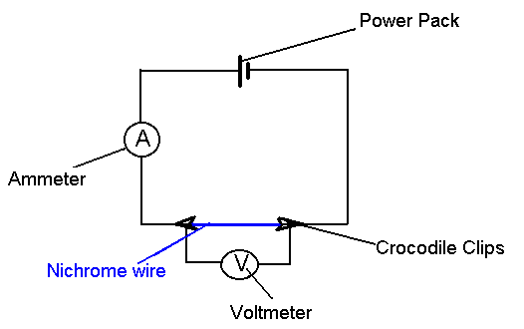

For the first trial, she uses 40-cm long, 0.5 mm diameter piece of wire. She obtains the following results:

|  |  |  |
| --- | --- | --- |
| **Potential across wire (V)** | **Current (A)** | **Resistance (Ω)** |
| 1.0 | 1.0 | 1.0 |
| 2.0 | 2.0 | 1.0 |
| 3.0 | 3.0 | 1.0 |
| 4.0 | 3.7 | 1.1 |
| 5.0 | 4.2 | 1.2 |

1. To what degree, if any, is this metal behaving as an *ohmic* conductor? Explain. (2)
2. Use the kinetic theory of matter to suggest and justify a reason why the resistance of the wire increased at higher applied voltages.

(2)

1. The student repeated the experiment with a second piece of nichrome wire which had the same length but a larger diameter. Would you expect its resistance to be larger, smaller or the same as the first? Explain. (2)

**Question 10 (9 marks)**

Uranium-238 (U-238) is a radioisotope and an α-emitter. The data below will be of use to you in this question. You will also need to refer to the Periodic Table in the Formulae and Constants Sheet.

**[Note – when performing calculations in this question – and answers - do NOT round to three (3) significant figures. Use as many significant figures as practical]**

|  |  |
| --- | --- |
| **Particle** | **Atomic Mass (u)** |
| **U-238** | **238.05079** |
| **Proton** | **1.00727** |
| **Neutron** | **1.00867** |

1. Use the above data to perform a calculation showing that the **mass defect** for a U-238 nucleus is **about 1.90 u**. (3)
2. Hence, calculate the **binding energy per nucleon** for a U-238 nucleus **in MeV**.

(3)

c) Ni-62 has one of the highest binding energy per nucleon of any known isotope - with a value of 8.7945 MeV.

Compare this value with the corresponding value for U-238 calculated in part b). Use this comparison to compare the stability of a Ni-62 nucleus versus a U-238 nucleus and to explain their contrasting properties in this regard. As part of your answer, you must discuss the presence of the strong force in each nucleus.

(3)

**Question 11 (14 marks)**

A student performs an experiment to calculate the temperature of a Bunsen burner flame.

A piece of copper with mass 250 g is held in the Bunsen flame for a few minutes. The copper metal is then transferred as quickly as possible to a copper calorimeter of mass 40.0 g containing 0.285 kg of water. The calorimeter and the water are initially at a temperature of 15.0°C.

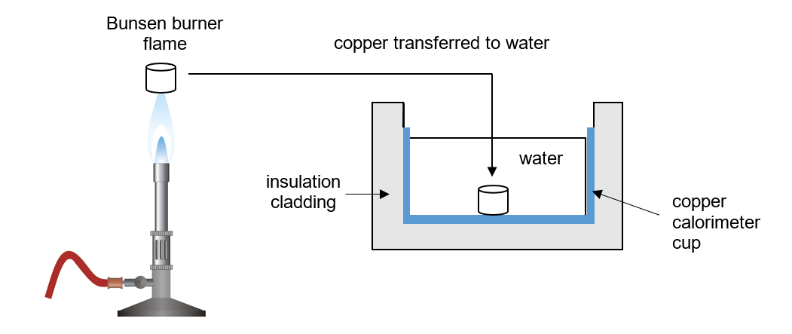

After the piece of copper is placed in the water, the water is stirred until a thermal equilibrium temperature of 80.0°C is achieved. Assume that heat losses to the surroundings of the water and the insulated cladding of the calorimeter are negligible. The specific heat capacity of copper is 390 J kg-1°C-1.

1. Calculate the quantity of thermal energy absorbed by the water and the copper calorimeter.

(3)

1. Using your answer from part b), calculate the temperature of the Bunsen burner flame. Show all working and assumptions you made while doing this calculation.

(4)

1. In reality, heat will be lost to the surroundings of the copper calorimeter and water. Explain the effect of this heat loss on the temperature of the Bunsen flame calculated in part b). Give clear reasoning.

(3)

1. The student decides to find a lid for the calorimeter to reduce heat loss from the water to the atmosphere.
   1. The student finds a clear glass lid which fits nicely on top of the calorimeter. Explain one major way in which this lid will assist to reduce heat loss. (2)
   2. Another student suggests using a lid made of mirrored glass. Suggest a possible advantage of using mirrored glass. Explain. (2)

e) “It is impossible to add thermal energy to a substance without causing a temperature increase.” Do you agree or disagree with this statement? Explain, briefly, your choice. Again, include the concept of internal energy in your answer.

(3)

**Question 12 (15 marks)**

Three resistors are connected in the circuit as shown in the circuit diagram below.

The voltage supplied to the circuit by the battery is 12 V. The table below shows the values of the three resistors shown.

|  |  |
| --- | --- |
| **R1** | **12.0 Ω** |
| **R2** | **6.00 Ω** |
| **R3** | **4.00 Ω** |

**R1**

**A1**

**A2**

**R3**

**R2**

**12 V**

**V1**

1. Calculate the total resistance (RT) of the circuit. Assume the resistance of the potential difference supplied and the wires is negligible.

(3)

b) Calculate the reading on the ammeter, A1. Show working.

(2)

c) Calculate the reading on the voltmeter, V1. Show working.

(2)

d) Hence, calculate the reading on the ammeter, A2. Show working.

(2)

e) A **9.60-Ω** resistor, **R4**, is added to the circuit. Calculate the power that is now dissipated by this new resistor. (3)

**R1**

**A1**

**R3**

**R2**

**R4**

**A2**

**12 V**

**V1**

f) If another resistor, R5, is placed in parallel with R2 and R3, will this new resistor increase or decrease the reading on A1? Justify your answer (no calculations are necessary) (3)

**Section Two: Problem-solving 50% (90 Marks)**

This section has **seven (7)** questions. You must answer **all** questions. Write your answers in the

space provided. Suggested working time for this section is 90 minutes.

**Question 13 (16 marks)**

 A solar camp shower is a device to heat water for a shower when other sources of energy are unavailable. The bag is simply hung in a sunny spot for a period of time. A typical camp shower would hold 20.0 litres of water.

1. Explain why the bag is black in colour. (1 mark)

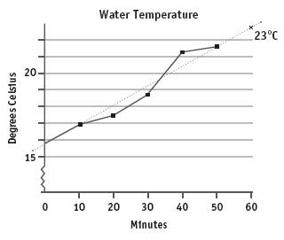

1. Examine the graph to the right, which shows how on a certain day, the temperature of water changes with time.
2. State and briefly explain one reason why the temperature of the water is not increasing at a constant rate.

(2 marks)

1. Use the graph’s line of best fit to calculate the average rate at which the water is heated. Express your answer in oC min-1.

(2 marks)

1. How long would it take to heat the water to 30oC ? (2 marks)
2. Calculate the amount of energy 20.0 litres of water needs to absorb to be heated from 15.8oC to 30.0oC.

(1 mark)

1. The average amount of solar radiation received at the Earth's surface is

1.37 × 103 Wm-2. The camp shower bag has an absorbing area of 0.40 m2.

1. Calculate the rate at which solar energy falls on the bag (2 marks)
2. If 100% of this energy was to go into heating water, how long would it take to heat 20.0 litres of water from 15.8oC to 30.0oC (3 marks)
3. Calculate the efficiency of the camp shower at converting the solar energy it receives into thermal energy in the water. (3 marks)

**Question 14 (14 marks)**

In an experiment, the current that passes through two separate resistors is measured as the voltage across them is changed. The results are shown in the graph below:



1. State whether *either, both or none* of the tested resistors are ohmic. Explain your answer. (2 marks)
2. Using the graph, determine the resistance of each, R1 and R2. Be sure to show your working.

(4 marks)

1. If the resistors are now joined in series, plot and label their combined resistance (Rc) on the graph above. (3 marks)
2. If the current running through the series circuit is 1.8 A, determine the Potential Difference of the battery powering the circuit. (2 marks)
3. The two resistors are now placed in parallel to the battery. An ammeter is placed in position to measure the current passing through R1 and a voltmeter is in position to measure the potential difference across R2. Draw a labelled diagram of the circuit as described

**Question 15 (11 marks)**

Nuclear Fusion is the process that powers our Sun and stars as smaller nuclei fuse together to form larger ones, and matter is converted into energy. When Hydrogen is heated to very high temperatures, its electrons are separated from the nuclei and the gas changes to a plasma. These high temperatures are also needed to overcome strong repulsive forces.

1. Describe the origin of the “strong repulsive forces” mentioned above. (2 marks)
2. As the temperature of the plasma rises, describe two things that happen to the particles within it. (2 marks)
3. Write a nuclear equation for the fusion of a Deuterium ( ${}_{1}^{2}H)$ nucleus and a Tritium ( ${}_{1}^{3}H)$ nucleus to form a ${}_{2}^{4}{He}$ nucleus, one other particle and energy. (2 marks)

1. Given the data below, determine the amount of energy (in J) released by each such reaction. (5 marks)

m( ${}_{1}^{2}H)$ = 2.01410178 u

m ( ${}_{1}^{3}H)=$ 3.01604927 u

m $({}_{2}^{4}{He})$ = 4.00260325 u

**Question 16 (8 marks)**

Fuses provide a way of protecting people against electrocution. They are generally a short length of wire which is designed to melt when the current in the circuit exceeds a certain amount.

1. Describe why the wire will melt when a high current passes through it. (2 marks)
2. Explain what would have to happen to the resistance of a circuit for the current to increase, and what might cause this to happen. (2 marks)
3. In a house, a lighting circuit might use a 20A fuse, whilst an oven would use 40A. State which of these circuits would use a fuse with a thicker wire. (1 mark)

1. State one disadvantage of fuses, compared to a residual current device (RCD).

(1 mark)

1. List two other electrical safety devices or features commonly used in a home. (2 marks)

**Question 17 (16 marks)**

When an object such as a metal rod is heated, its length will almost always increase. A measure of the rate at which this increases is called the coefficient of linear expansion $α_{L}$. It is the fractional change in length per degree of temperature change, and can be expressed as:

{\displaystyle \alpha _{L}={\frac {1}{L}}\,{\frac {dL}{dT}}}

where  is the initial length of the sample material, {\displaystyle L} is the amount by which it has expanded and  {\displaystyle dL/dT} is the change in temperature.

This equation works well as long as the linear-expansion coefficient does not change much over the change in temperature, {\displaystyle \Delta T}and the fractional change in length $\frac{∆L}{L_{o}}$ is small.{\displaystyle \Delta L/L\ll 1}{\displaystyle {\frac {\Delta L}{L}}=\alpha _{L}\Delta T}

In an experiment to determine the coefficient of linear expansion of Aluminium, a sample of

known length, 6.00 × 102 mm was placed in a sealed chamber, and heated with steam at

100oC, then allowed to cool. The length of the bar was recorded each drop of 2oC until the

Temperature inside the chamber reached 50oC.

1. Explain, using the Kinetic particle model of matter, why substances expand when heated.

(2 marks)

1. State what assumption must be made when collecting data for the temperature of the sample.

The results for the experiment until temp = 80 oC are as follows:

|  |  |  |
| --- | --- | --- |
| ΔTemp (oC) | (mm) |  |
| -1 | 0.99 | 0.00165 |
| -4 | 0.97 | 0.001617 |
| -6 | 0.94 |  |
| -8 | 0.92 |  |
| -10 | 0.9 | 0.0015 |
| -12 | 0.87 | 0.00145 |
| -16 | 0.82 | 0.001367 |
| -18 | 0.79 |  |
| -20 | 0.77 |  |

1. Complete the third column, $\frac{∆L}{L_{o}}$ in the table above. Some values are already done.

(2 marks)

1. On the graph paper provided, plot a graph of $\frac{∆L}{L_{o}}$ on the y-axis and ΔT on the x-axis. You must label your axes. (A spare grid is supplied at the end of the paper) (4 marks)
2. Draw the line of best fit for your data. (1 mark)
3. Using your line of best fit, calculate the coefficient of linear expansion for the sample used. Show all relevant calculations and working. (4 marks)
4. The theoretical value of αL for Aluminium is 23.8 × 10-6 oC-1. Calculate the percentage error in the experimental value obtained. (If you were unable to calculate a value for part f, use 23.0 × 10-6 oC-1). (2 marks)

**Section Three: Comprehension**

This section contains **one** question. You must answer both questions. Write your answers in

the spaces provided. Suggested working time for this section is 40 minutes.

**Question 18 (20 marks)**

**Chernobyl Nuclear Accident**

The catastrophic nuclear accident known as the ‘Chernobyl Disaster’ occurred on the 25th of April, 1986 at the Chernobyl Nuclear Power Plant in Northern Ukraine. The accident occurred during a late night safety test which was simulating a power failure resulting in a station blackout.

A complete station blackout would cause the plant’s safety systems to cease functioning. On the night of the 25th April, as part of the test, technicians deliberately removed nearly all of the control rods from the reactor core. This, along with several other actions, deliberately created a power surge in the reactor. In short, the reactor was put in an extremely unstable position (called ‘super-criticality’) that would require manual intervention from the technicians in the control room of the plant. This was all part of the planned test.

Unfortunately, as the rector went ‘super critical’, more and more coolant water in the reactor ‘flashed’ into steam. The extreme pressure of the steam in the reactor vessel blew the containment structure apart – including the roof of the containment building, exposing the radioactive interior to the outside atmosphere.

The explosion ejected large amounts of radioactive nuclear fuel into the atmosphere. Fission fuel (Uranium-235 was the fissile fuel used at Chernobyl) and far more dangerous fission products such as caesium-137, Iodine-131, Strontium-90 and other radionuclides were dispersed into the atmosphere. One positive consequence of the explosion was that the nuclear fission reaction occurring in the reactor core was effectively terminated by the dispersal of fissile material. However, a disastrous situation was unfolding.

Radiation levels in the plant immediately after the accident were enormous. A dose equivalent to about 5 Sieverts (5 Sv) is usually lethal to a human being. The table below shows the radiation levels at some specific locations at the plant.

|  |  |
| --- | --- |
| **Location** | **Sieverts per Hour** |
| **Vicinity of the reactor core** | **300** |
| **Debris heap at the circulation pumps** | **100** |
| **Fuel fragments on roof of containment building** | **175** |
| **Control Room** | **0.04** |

Many workers, fire fighters and first responders to the accident were exposed to very high radiation levels and many died within a short time after the accident. Firefighters were sent to the roof of the containment building – limited to short periods of time in order to limit their exposure. However, many of the fire fighters died from radiation sickness not long after their heroic work was completed.

The high radiation levels and large dispersal of radioactive materials in the surrounding area necessitated a mass evacuation from the surrounding areas. Residents in the nearby town of Pripyat were not evacuated until 11.00am on the 26th April and many exhibited signs of radiation sickness – e.g. vomiting, headaches, pins and needles on exposed skin. Many of these residents later developed health problems connected to their exposure.

Immediately after the evacuation, an exclusion zone (i.e. a place where humans are not allowed to enter) was set up around the power plant with a radius of about 30 kilometres. Its borders were then extended so that this exclusion zone now covers a larger area of about 2600 square kilometres. It is one of the most radioactively contaminated areas in the world; because of this, it is of significant interest to scientists – especially those studying the effect of high levels of radiation exposure in the environment.

As the radiation levels in the outer parts of this zone have slowly decreased, talks have recently begun (in February, 2019) to redraw the boundaries and reduce the size of the exclusion area.

1. The planned safety test at Chernobyl involved the deliberate removal of the reactor’s control rods. Describe the effect that this removal would have had in the reactor core. As part of your answer, describe the role that the control rods have in a nuclear reactor.

(4)

Uranium-235 was the main fission fuel used in the Chernobyl reactor. Uranium-235 is an alpha emitter with a half-life of 4.5 billion years. Its nuclei have a mass of 235.0439299 u. The periodic table on the Formulae and Constants Sheet will be needed for parts b) and c).

One possible fission reaction involving uranium-235 is described in words below:

A slow-moving neutron collides and is captured by a uranium-235 nucleus; the nucleus splits and forms the fission products rubidium-90, caesium-143, some neutrons and a large amount of thermal energy.

1. Write a balanced nuclear equation depicting the fission reaction described above. Determine the number of neutrons produced in this reaction and state this clearly in the equation.

(2)

Another possible fission reaction is described in the nuclear equation below:

$$U_{92}^{235} + n_{0}^{1} → {Sr}_{38}^{90}+ {Xe}_{54}^{143}+3n_{0 }^{1}+energy$$

The relevant atomic masses for the reactants and products in this reaction are shown in the table below:

|  |  |
| --- | --- |
| **U-235** | **235.0439299 u** |
| **Neutron ($n_{0}^{1}$)** | **1.00867 u** |
| **Sr-90** | **89.907738 u** |
| **Xe-143** | **142.935370 u** |

1. Calculate the quantity of energy released (in MeV) during this fission reaction. Show all working. [Do NOT round to three (3) significant figures in this calculation]

(4)

1. Hence, calculate the energy released (in Joules) if 1.00 kg of U-235 nuclei completely undergo fission as per the reaction in part c). If you could not get an answer for part c), use a value of 200 MeV.

(3)

The table below shows some of the properties of the radioisotopes that were ejected from the fuel rods during the explosion.

|  |  |  |
| --- | --- | --- |
| **Radioisotope** | **Radiation emitted** | **Half Life** |
| Uranium-235 | α-emitter | 4.5 billion years |
| Caesium-137 | β-emitter | 30.2 years |
| Iodine-131 | β-emitter | 8 days |
| Strontium-90 | β-emitter | 28.8 years |

1. In the article, the following statement is made:

“Fission fuel (uranium-235 was the main fissile fuel used at Chernobyl) and far more dangerous fission products such as caesium-137, Iodine-131, strontium-90 and other radionuclides were dispersed into the atmosphere.”

Using the data above, provide explain why the three fission products mentioned are ‘far more dangerous’ than uranium-235.

(3)

1. Before the exclusion zone was extended, an average male living in the outer area was absorbing approximately 130 mJ of **slow neutron radiation** each day. Estimate the dose equivalent such a person acquired in the 2 months before the area was evacuated. Report your answer in appropriate units.

(4)

prac exam youngs mod 10 by 10

**End of examination**